Melodious Eras

Faysal Sharif

Joseph Hart

Muhammad Naviwala

Thi

Zachary Kaspar

Version 1.A

Table of Contents

Overview 1

Characters 2

Story 3

Gameplay 4

Level Design 5

Art 6

Sound and Music 7

User Interface and Game Controls 8

Overview

Melodious Eras is rhythm platformer sidescroller game designed for Windows Phone 8 and is rated E for everyone.

Characters

**Draco Soprano** – The games protagonist. This young, ambitious and curious scientist wants to travel through time.

Story

Draco Soprano is a young and curious scientist who has always dreamt about travelling thorough time. He decides to build a music powered time machine for this purpose because he wants a wild adventure through time. He was able to create the time machine but there were some mechanical problems which he must fix in order to start his adventure. He fixes the mechanical problem by playing the 8-bit melody with the help of user interactions (tutorial level) and is able to start his time machine!

Draco had a keen look in his eyes because he knew his dream was about to come true in matter of seconds. He punched in 1920 to go the Jazz era as Jazz was his favorite music (first level). After couple of hours Draco decided he wanted to come back home in real time. But to his horror the time machine malfunctions and he can’t come back to real time. No matter how hard he tried the time machine kept sending him to random eras.

Draco realized he doesn’t have a choice but to reset the time machine and in order to do that he must play the master melody. That of course was not an easy task. He must go to each era the time machine sends him and get parts of the master melody. Draco was about to have an adventure of lifetime…

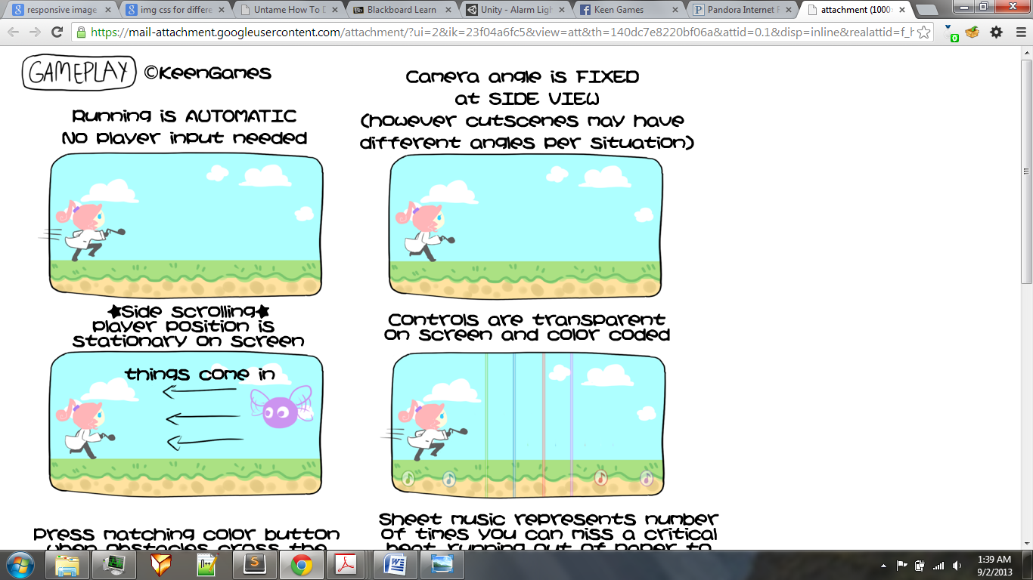Gameplay

The players position on the screen is stationary and running is automatic. The camera angle is fixed at side view. However some cut scenes may have different angles.

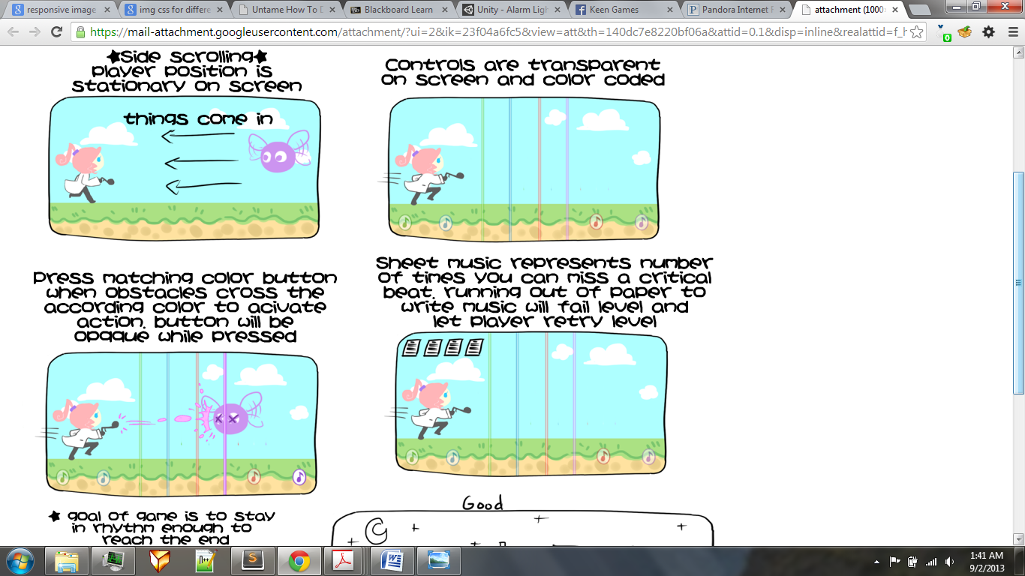

The control buttons are transparent on the screen and color coded.



The player must hit the right color button to clear obstacles.

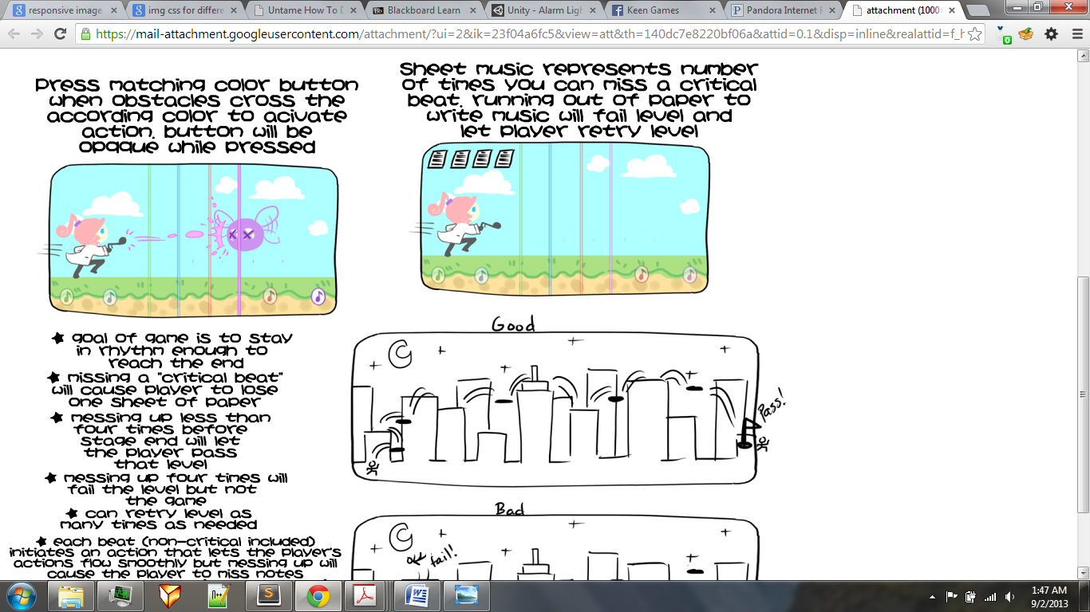

The number of sheets on the top-left corner of the screen will present how many beats the player can miss before time runs out.

Level Design

There will be minimum of 10 eras with 6 levels per era plus the tutorial level. Each era will represent a different music genre. The possible music genres/eras are listed below:

1. Stone age
2. Medieval and Renaissance
3. Oriental (traditional)
4. Classical/Romantic
5. Folksy music
6. Western
7. Jazz
8. Pop
9. Techno
10. Futuristic

Each level will have music sheets on the top-left corner of the screen which will present how many beats the player can miss before time runs out.

On the top-right corner will be the score.

On the bottom of the screen will be the controls which the player will interact with.

The players position and the lines in between **(CHANGE)** will have a stationary position (except in some cut scenes)

Art

Draco Soprano

Sound and Music

Game sounds:

To be decided.

Music:

Will depend on the music era.

User Interface and Game Controls

The user will interact with 4 buttons and must press the right colored button to avoid obstacles.

